**Calculating Family Expenses using Service Now**

**Team Id : NM2025TMID17002**

**Team Members: 04**

**Team Leader: V. BHUVANESHWARI**

**Team Member 1: P. MOHANRAJ**

**Team Member 2: M. PARANTHAMAN**

**Team Member 3: S. RAVISANKAR**

**Problem Statement:**

**Families face difficulty in managing and tracking their monthly expenses.**

**There is no proper system to record and categorize spending.**

**This leads to poor financial planning and lack of clarity in savings.**

**A ServiceNow app is needed to calculate, analyze, and report expenses.**

**Objective:**

**To develop a ServiceNow-based application that helps families record, categorize, and calculate their expenses, and provides reports for better financial planning and analysis.**

**Skills:**

**ServiceNow Platform Knowledge – Tables, Forms, Lists, Modules**

**Application Development in ServiceNow – Creating custom apps**

**Scripting – Client Script, Business Rule, Script Include (JavaScript)**

**Workflow / Flow Designer – Automating expense approvals or reports**

**Reporting & Dashboards – Charts, graphical reports for expenses**

**Basic Database Knowledge – Storing and retrieving expense records**

**Analytical Skills – Categorizing and analyzing expenses**

**TASK INITIATION**

### Milestone 1: Setting up ServiceNow Instance

### Milestone 1:Setting up ServiceNow Instance

### Activity 1:Setting up ServiceNow Instance

1. Sign up for a developer account on the ServiceNow Developer site “https://developer.servicenow.com”.
2. Once logged in, navigate to the "Personal Developer Instance" section.
3. Click on "Request Instance" to create a new ServiceNow instance.
4. Fill out the required information and submit the request.
5. You'll receive an email with the instance details once it's ready.
6. Log in to your ServiceNow instance using the provided credentials.
7. Now you will navigate to the ServiceNow.

### Milestone 2:Creation of New Update Set

### Activity 1:Creation of New Update Set

1. Go to All >> In the filter search for Local Update set > click on New.

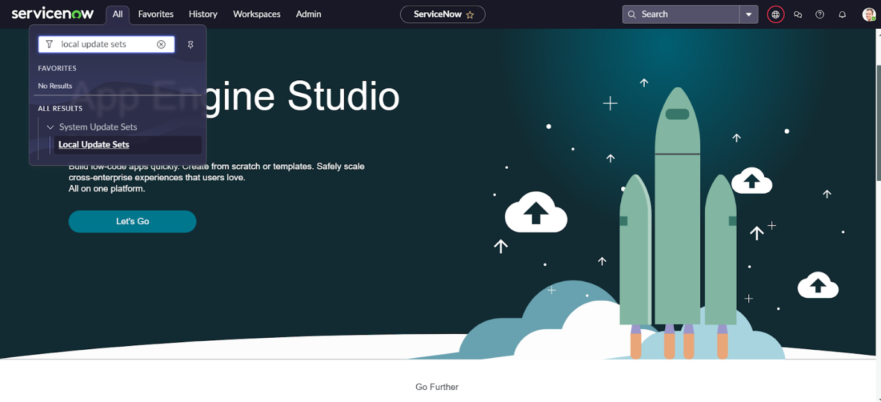

1. Enter the Details as:

Name : Family Expenses

1. Then click on Submit and Make current.

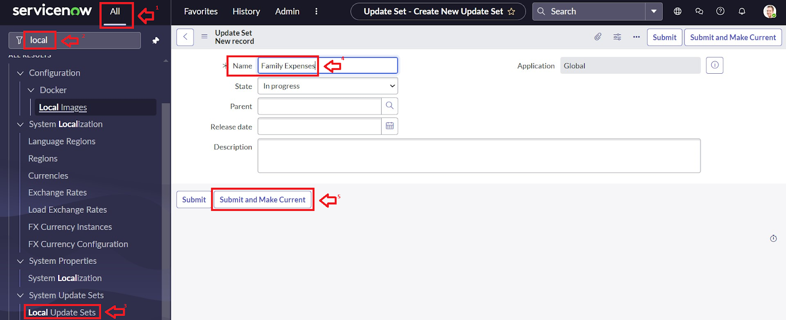

### Milestone 3:Creation of Table

### Activity 1:Creation of New Update Set

1. Go to All >> In the filter search for Local Update set > click on New.



1. Enter the Details as:

Name : Family Expenses

1. Then click on Submit and Make current.



### Milestone 4:Creation of Table

### Activity 1:Creation of Family Expenses Table

1. Go to All > In the filter search for Tables > click on New.
2. Enter the Details:

Label : Family Expenses

Name : Auto-Populated

New menu name : Family Expenditure

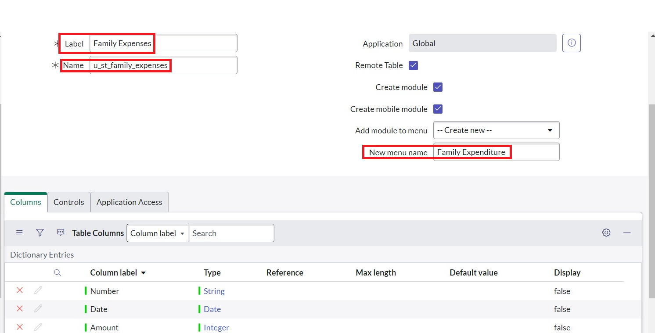

1. Go to the Header and right click there>> click on Save.

### Activity 2:Creation of Columns(Fields)

1. Near Columns Double click near insert a new row.
2. Give the details as:

Column label : Number

Type : String

1. Double click on insert a new row again
2. Give the details as:

Column label : Date

Type : Date

1. Double click on insert a new row again
2. Give the details as:

Column label : Amount

Type : Integer

1. Double click on insert a new row again
2. Give the details as:

Column label : Expense Details

Type : String

Max length : 800

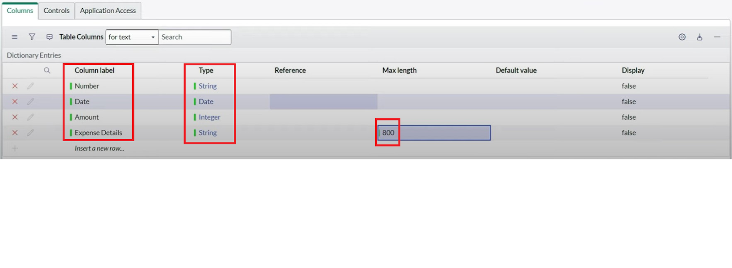

1. Go to the Header and right click there>> click on Save.

### Activity 3:Making Number Field an Auto-Number

1. Double click on the Number Field/Column.
2. Go down and double click on Advanced view
3. In Default Value:

Use dynamic default : check the box

Dynamic default value : Get Next Padded Number

1. Click on Update.

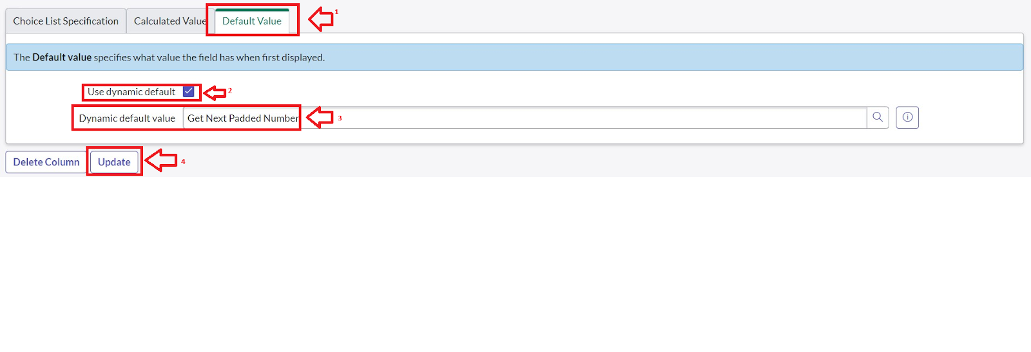

6. Go to All >> In the filter search for Number Maintenance >> select Number Maintenance

7.Click on New.

8.Enter the below Details:

Table : Family Expenses

Prefix : MFE

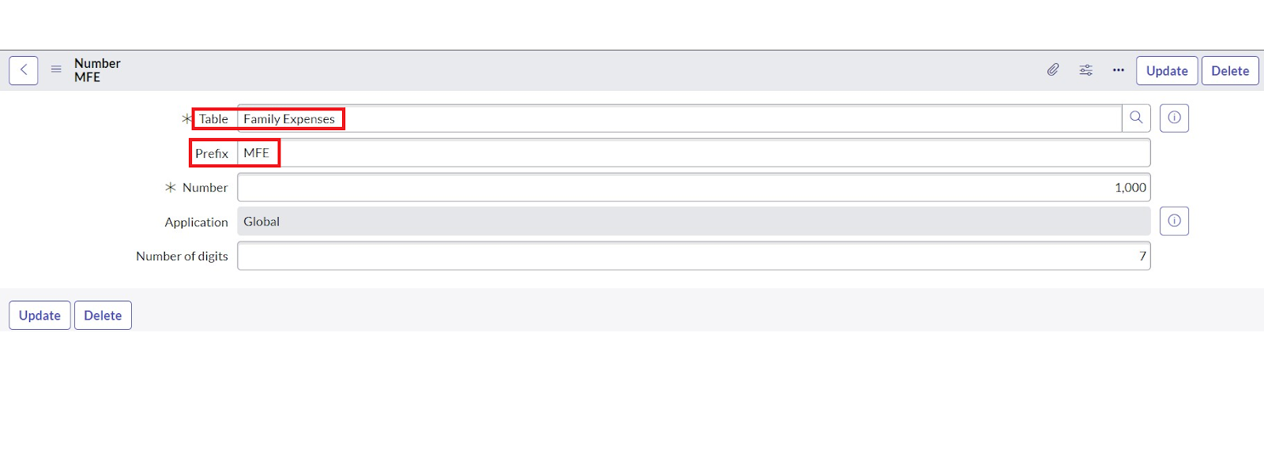

1. Click on Submit.

### Activity 4:Configure the Form

1. Go to All >> In the filter search for Family Expenses >> Open Family Expenses
2. Click on New
3. Go to the Header and right click there>> click on Configure >> Select Form Design
4. Customize or Drag Drop the form as per your requirement.

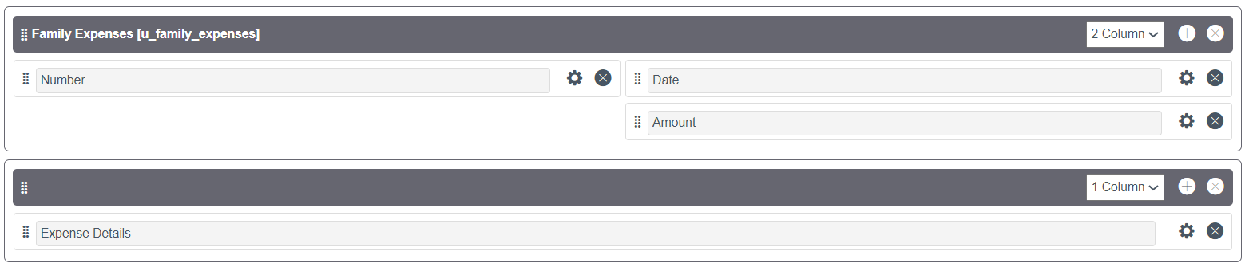

1. Make Number Read-Only Field by clicking on the gear icon and checking Read-Only
2. Make Date, Amount Mandatory Field by clicking on the gear icon and checking Mandatory
3. Click on Save.

### Milestone 5:Creation of Table(Daily Expenses)

### Activity 1:Creation of Daily Expenses Table

1. Go to All > In the filter search for Tables > click on New.
2. Enter the Details:

Label : Daily Expenses

Name : Auto-Populated

Add Module to menu : Family Expenditure

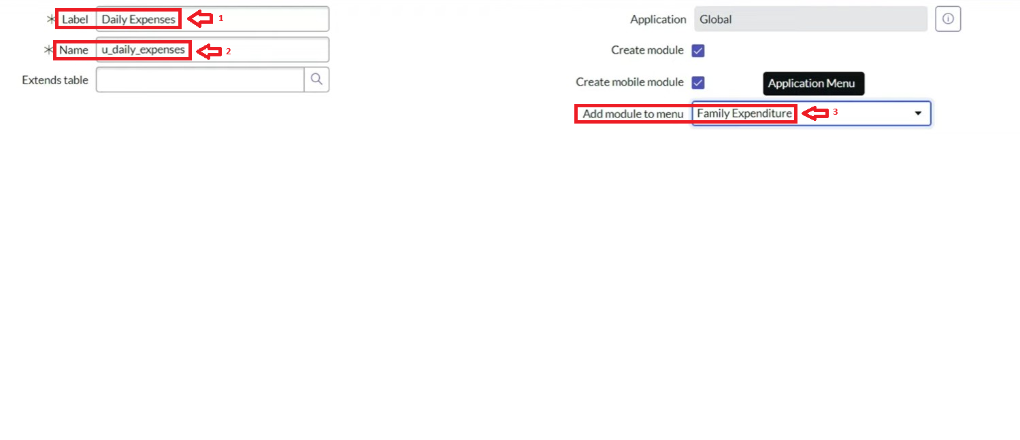

1. Go to the Header and right click there>> click on Save.

**Activity 2:Creation of Columns(Fields)**

1. Near Columns Double click near insert a new row.
2. Give the details as:

Column label : Number

Type : String

1. Double click on insert a new row again
2. Give the details as:

Column label : Date

Type : Date

1. Double click on insert a new row again
2. Give the details as:

Column label : Expense

Type : Integer

1. Double click on insert a new row again
2. Give the details as:

Column label : Family Member Name

Type : Reference

Max length : 800

1. Double click on insert a new row again
2. Give the details as:

Column label : Comments

Type : String

Max length : 800

1. Go to the Header and right click there>> click on Save.

### Activity 3:Making Number Field an Auto-Number

1. Double click on the Number Field/Column.
2. Go down and double click on Advanced view
3. In Default Value:

Use dynamic default : check the box

Dynamic default value : Get Next Padded Number

1. Click on Update.
2. 
3. Go to All >> In the filter search for Number Maintenance >> select Number Maintenance
4. Click on New.
5. Enter the below Details:

Table : Family Expenses

Prefix : MFE

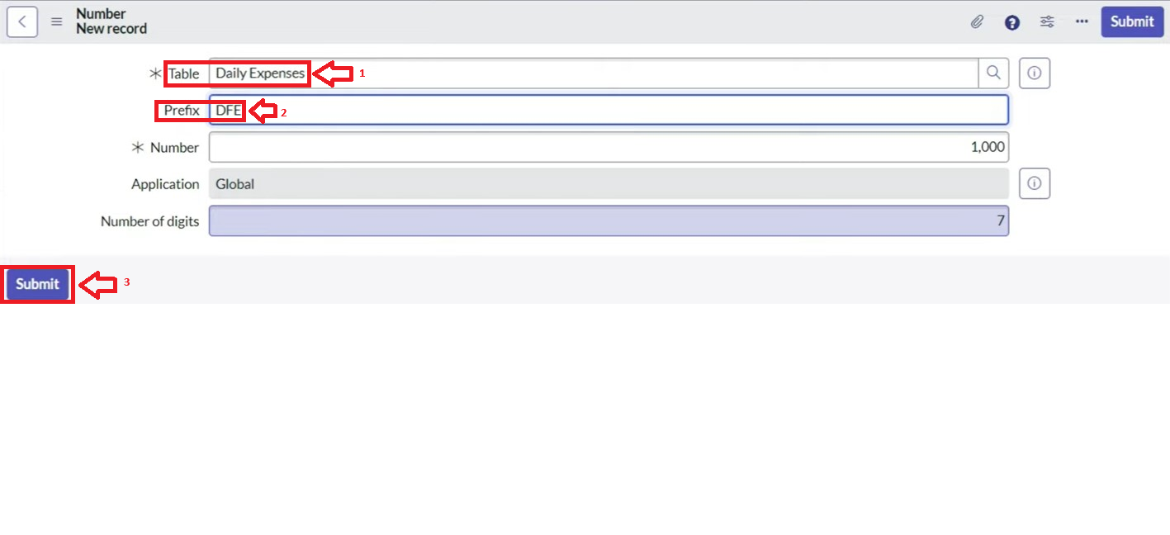

1. Click on Submit.

### Activity 4:Configure the Form

1. Go to All >> In the filter search for Daily Expenses >> Open Daily Expenses
2. Click on New
3. Go to the Header and right click there>> click on Configure >> Select Form Design
4. Customize or Drag Drop the form as per your requirement.

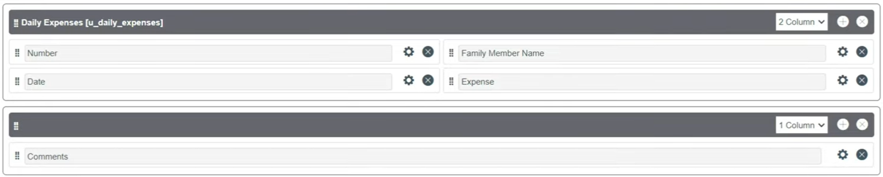

1. Make Number Read-Only Field by clicking on the gear icon and checking Read-Only
2. Make Date, Family Member Name Mandatory Field by clicking on the gear icon and checking Mandatory
3. Click on Save.

### Milestone 6:Creation of Relationship

### Activity 1:Creation of Relationship between Family Expenses and Daily Expenses tables

1. Go to All >> In the filter search for Relationships >> Open Relationships
2. Click on New.
3. Enter the details:

Name : Daily Expenses

Applies to table : Select Family Expenses

Daily Expenses : Select Daily Expenses

1. Click Save.

### Milestone 7:Configuring Related List on Family Expenses

### Activity 1:Configuring Related List on Family Expenses

1. Go to All >> In the filter search for Family Expenses >> Open Family Expenses
2. Click on New
3. Go to the Header and right click there>> click on Configure >> Select Related Lists
4. Add Daily Expenses to the Selected Area.
5. Click on Save

### https://lh7-us.googleusercontent.com/docsz/AD_4nXd6O6Ji5ozI6Do_ppbat1Eii8kkO4f8NUcYXyCTWwtgg6hTmJfHniRQN3ZU4715UML0w2ITsku5fQbyFczF8nDRYJzPgGILL6ENG3E0k3xWqDuQnV73o2Dbl0m8FCEAe7PxTJrO76FeIfLarMYk6y36qrc?key=-Pa05b-NAQDbQlQnuZQ_egMilestone 8:Creation of Business Rules

**Activity 1:Creation of Business Rules**

1. Go to All >> In the filter search for Business Rules.
2. Under System Definition Select Business Rules then click on New.
3. Enter the Details:

Name : Family Expenses BR

Table : Select Daily Expenses

Check Advanced

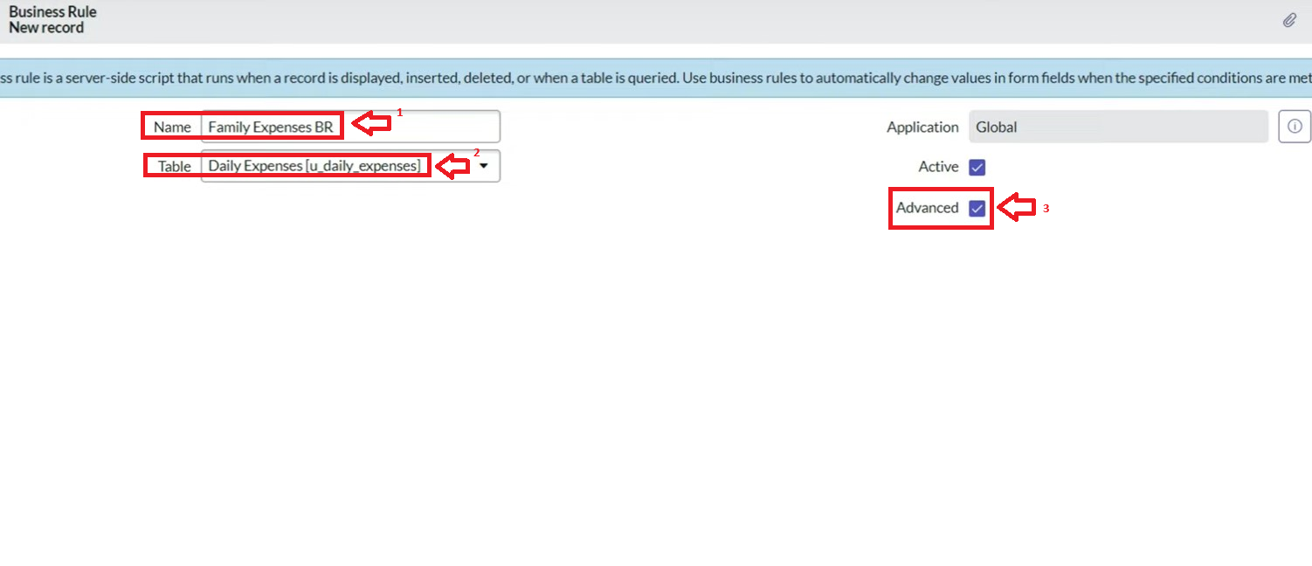

1. In when to run Check Insert and Update

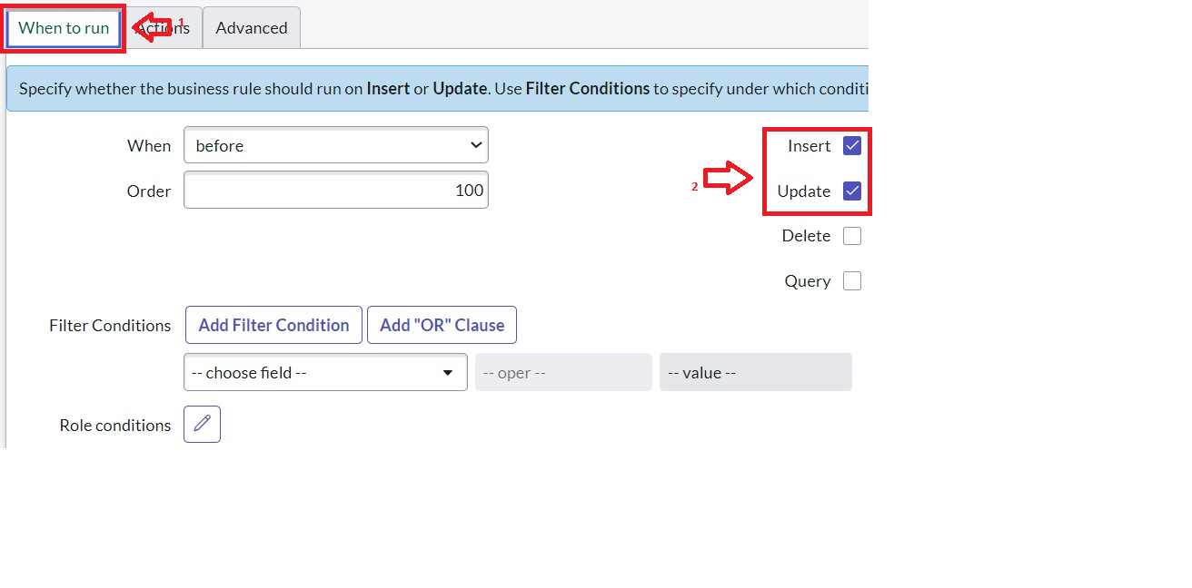

1. In Advance(we write the code): Write the below code >>

(function executeRule(current, previous /*null when async*/) {

var FamilyExpenses = new GlideRecord('u_family_expenses');

FamilyExpenses.addQuery('u_date',current.u_date);

FamilyExpenses.query();

if(FamilyExpenses.next())

{

FamilyExpenses.u_amount += current.u_expense;

FamilyExpenses.u_expense_details += ">"+current.u_comments+":"+"Rs."+current.u_expense+"/-";

FamilyExpenses.update();

}

else

{

var NewFamilyExpenses = new GlideRecord('u_family_expenses');

NewFamilyExpenses.u_date = current.u_date;

NewFamilyExpenses.u_amount = current.u_expense;

NewFamilyExpenses.u_expense_details += ">"+current.u_comments+":"+"Rs."+current.u_expense+"/-";

NewFamilyExpenses.insert();

}

})(current, previous);

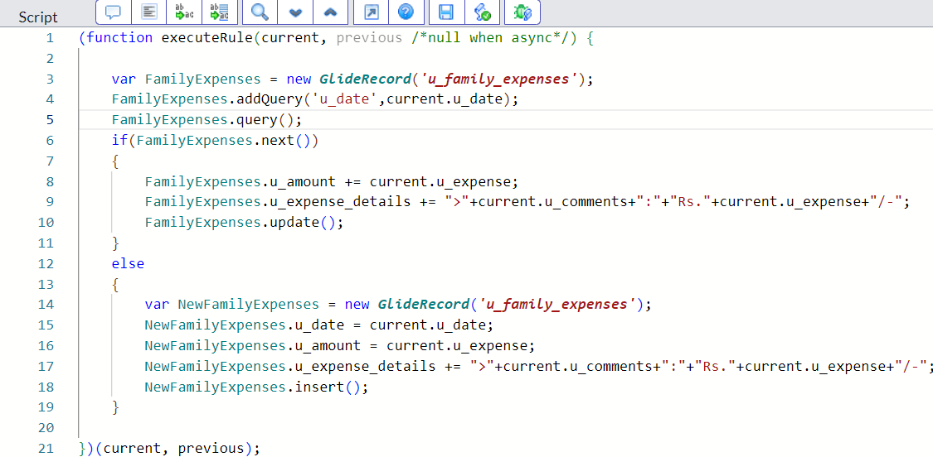

1. Go to the Header and right click there>> click on Save.

### Milestone 9:Configure the Relationship

**Activity 1:Configure the Relationship**

1. Go to All >> In the filter search for Relationships >> Open Relationships.
2. In that, open Daily Expenses Relationship.
3. For Applies to table : Select Family Expenses.
4. In Query with : write the below Query.

(function refineQuery(current, parent) {

// Add your code here, such as current.addQuery(field, value);

current.addQuery('u_date',parent.u_date);

current.query();

})(current, parent);

1. Click on Update.

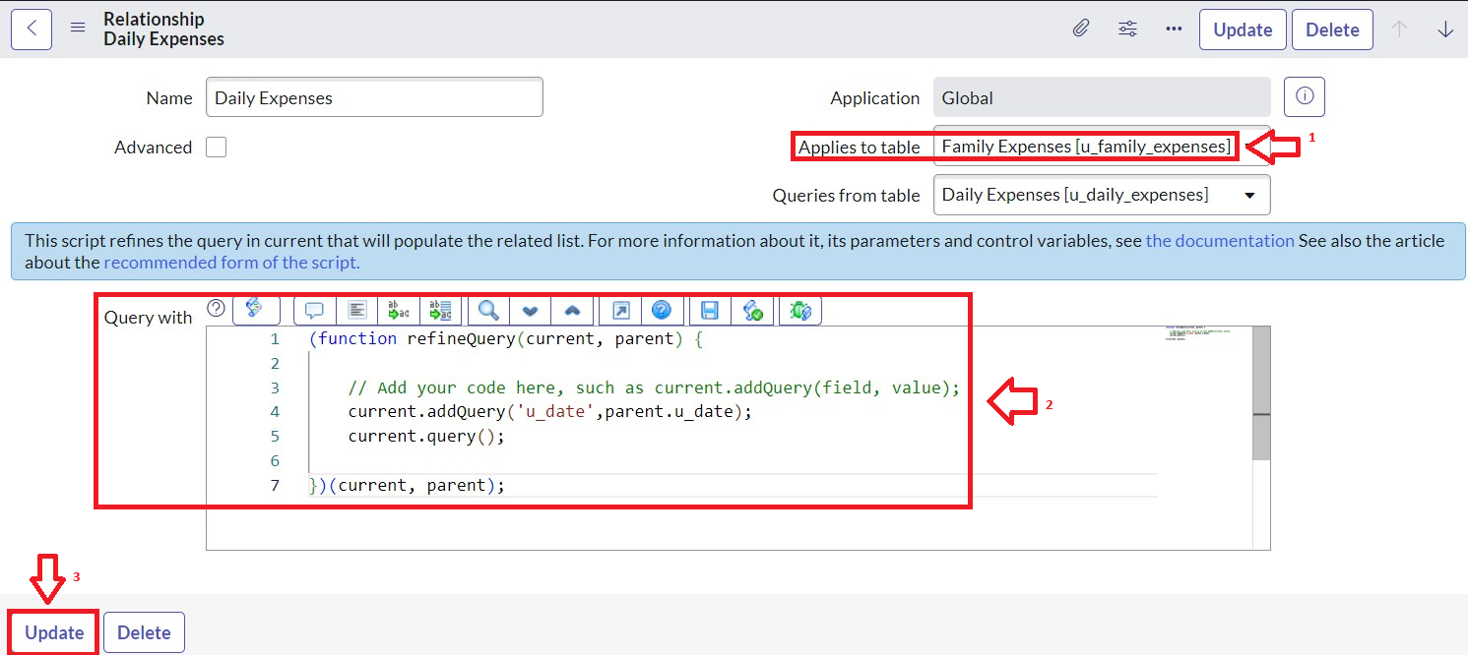

### Conclusion

By implementing expense calculation in ServiceNow, families can automate record-keeping, gain insights through dashboards, and maintain better financial control. This improves savings, reduces wastage, and ensures long-term financial stability.”